SCH4U - Acid-Base Review

- What is the definition of an Arrhenius Acid? Base?

- What is the definition of a Bronsted-Lowry acid? Base?

- Name 2 everyday acids and 2 everyday bases.

- What is the definition of strong acids and bases?

- What is the definition of weak acids and bases?

- List the strong acids.

- Give an example of a weak acid.

- List the strong bases.

- Give an example of a weak base.

- What is the formula for pH?

- What is the formula for pOH?

- What is the pH of HCl with a concentration of 0.1M?

- What is the pOH of H2SO42- if its concentration is 0.05M?

- What type of reaction is this: HCl + NaOH NaCl + H2O?

- What is an acid-base indicator?
- What is the best indicator to use to identify a basic substance around a pH of 8?

- What is the concentration of [H+] and [OH-] ions at the equivalence point shown below?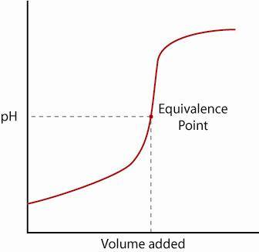

- Draw a sketch of the titration of a strong base with a weak acid.

- What is the pOH if the [H+] is 0.2M?

- Identify the acid, base, conjugate acid, conjugate base:
HS⁻(aq) + H₂O(l) ↔ H₂S(aq) + OH⁻ (aq)

- What is the [OH-] in a solution with a pH=9?

